H.T No
Regulations:
A18

Sreenidhi Institute of Science and Technology
(An Autonomous Institution)
Code No:7D301 Date: 31-Oct-2020 (FN)

B.Tech II-Year I-Semester External Examination, October - 2020 (Supplementary)
DISCRETE STRUCTURES AND GRAPH THEORY (ECM)

Time: 2 Hours Max.Marks:70

Note: a) No additional answer sheets will be provided.
b) All sub-parts of a question must be answered at one place only, otherwise it will not be valued.
c) Missing data can be assumed suitably.

ANSWER ANY 5 OUT OF 8 QUESTIONS. EACH QUESTION CARRIES 14 MARKS.

1. | a) | Obtain the product of sums form of . | [7M]
 | b) | For the following statement i)Find symbolic form and ii)construct the truth table. “joe will get the prize iff either he is smart or jim is stupid”. | [7M]
2. |  | Write the following statements in symbolic form  i) Every one loves science fiction  ii)There is atleast one person who like math  iii)No one disagrees with me  iv) Not all birds can fly | [14M]
3. | a) | Explain about initial functions and show that f(x,y)= x* y is primitive recursive. | [7M]
 | b) | Let (z⁺,+),(Z⁺, .) be two semi-groups. Define f: (z⁺,+)(Z⁺, .) as f(m) = 2^{m} .Show that f is a semi-group homomorphism | [7M]
4. | a) | How many committees of 5 or more can be chosen from 9 people? | [7M]
 | b) | State pigeon-hole principle and hence show that if there are people in a room at least two of them have birthdays that occur on the same day of the week. | [7M]
5. |  | Solve . | [14M]
6. | a) | Define i) Planar graph ii)Euler graph iii) Hamiltonian graph. | [7M]
 | b) | Draw the graph k3,3 and find its chromatic number. | [7M]
7. | a) | Let f:N Z as f(n)=2n+5 .Show that f is one-one. Is f onto. | [7M]
 | b) | Let * be a binary operation on N with m*n= m + n+ k where k is a constant, Show that * is commutative and associative. | [7M]
8. |  | Define isomorphism of graphs and determine whether the graphs are isomorphic.  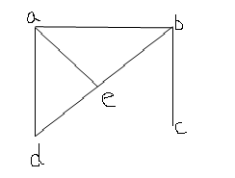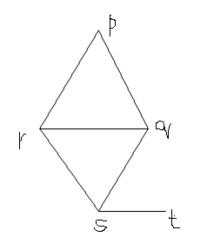 | [14M]

-- 00 -- 00 –

